**AWT Library**

**Introduction**

AWT – Popular java library for user interface development. Designed to develop user interfaces without worrying about mouse tracking or reading from keyboard.

A UI is built based on graphical elements called **components**. In AWT, all user interface elements are instance of the **class Component** or one of its subclasses. Components are found within **containers.** Containers **contain and control** the layout of components. Containers **are themselves components (container “is a” component)** and thus can be placed inside other containers. All containers are instances of **class Container** or one of its subclasses.

AWT provides **nine non-container component classes** that can be used to construct the user interface. These classes can be seen on the right in the image below. There are also **four container classes** that can be seen in the image below. Note that the applet class is also a container since it is a subclass of Panel and thus can hold components. **Window** and its subclasses are top level containers that cannot be embedded into other containers. **Frame and Dialog** are windows that have a border and title. **Panel** is a generic container that can be embedded into other containers. Inheritance hierarchy can be seen below:

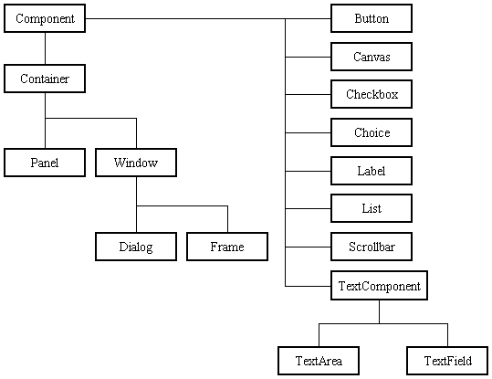

See the following URL for coding examples on how to use containers and components:

<http://www.javaworld.com/javaworld/jw-07-1996/jw-07-awt.html?page=2>

**Key Container methods**: add(X), pack(), show()

Layout is controlled not by the container, but by a **layout manager associated with the container**. The layout manager **makes all of the component placement** **decisions**. In the AWT, all layout manager classes implement the **LayoutManager** interface. AWT provides five different layout manager classes. The FlowLayout and BorderLayout will be used as an example since they are the default layout managers. **Each container class has a default layout manager**. The default layout manager for the Frame class and Dialog class is the BorderLayout manager. The default layout manager for the Panel class (and the Applet class) is the FlowLayout manager

The **FlowLayout** class places components in a container from left to right. When the space in one row is exhausted, another row is started. The single-argument version of a container's add() method is used to add components.

The **BorderLayout** class has five zones as depicted in Figure 7. The zones are named "North", "South", "East", "West", and "Center". A single component can be placed in each of these five zones. When the enclosing container is resized, each border zone is resized just enough to hold the component placed within.

**See example**: <http://www.javaworld.com/javaworld/jw-07-1996/jw-07-awt.html?page=3>

**Event Handling**

Actions are **handled by components** and how a user interface responds to user input. When an event occurs, an **ActionEvent** object is generated. The **ActionListener** interface listens for a particular ActionEvent and responds in its **actionPerformed** method. The **WindowListener** interface listens for events associated with Window objects, such as closing a window, and responds in corresponding methods.

**See example**: <http://www.cse.lehigh.edu/~glennb/oose/java/javaawt.htm>